Preparation of Manuscripts for the

2012 IEEE Real Time Conference
First A. Author, Second B. Author, Jr., and Third C. Author, Member, IEEE

Abstract–These instructions provide guidelines for preparing manuscripts for submission to the Conference Record (CR) of the 2012 IEEE Real Time Conference. If you are using Microsoft Word to prepare your manuscript, you should use this document as a template. Define all symbols used in the abstract. Do not cite references in the abstract. Do not delete the blank line immediately above the abstract; it sets the footnote at the bottom of this column.

INTRODUCTION
T
his document is a template for Microsoft Word. It provides instructions for authors that will be presenting a paper at the 2012 IEEE Real Time Conference (RT12), and should be used in preparing and submitting manuscripts to the Conference Record (CR). The Conference Record is a non-refereed, CD-ROM-based publication that is distributed to all conference attendees after the conference. A detailed description of the CR submission procedure is provided in section II below. The deadline for the submission of a manuscript to the CR is June 11, 2012.
Additionally, you may submit your manuscript to the IEEE Transactions on Nuclear Science (TNS), if it represents significant original contributions in the fields associated with the conference (i.e., progress reports and preliminary findings are not appropriate). The TNS is a refereed publication, and is published throughout the year. A “Conference Issue” of TNS dedicated to the RT12 conference is scheduled for publication in Early 2013. In order to be included in this special issue of TNS, all manuscripts must be received before the deadline; Go to the conference web page http://rt2012.lbl.gov/authorinfo.html for updated information about the submission to TNS. For instructions on TNS manuscript submissions, please visit the IEEE's on-line peer review system Manuscript Central™ (http://mc.manuscriptcentral.com/tns-ieee). Please note that submission to TNS is a separate process from that of the Conference Record.

Online Template
You can download this template, in both MS Word and PDF format, from the RT12 conference web site (http://rt2012.lbl.gov/authorinfo.html) so that you can use it to prepare your manuscript. A LaTeX style and sample files are also available from the same web page. For authors using word processors other than LaTeX or Word, Table I gives the font sizes and formats that are used in this document. Use “Times New Roman” font or its equivalent on your system. The preferred paper size is US Letter (8.5” ×11”). The height of the text is 9.6” (244mm), and width of each column is 3.5” (89mm), with a 0.2” (5mm) separation between columns. If you must use A4 paper size, please set the top and bottom margins to be 27mm, and left and right margins to 14mm to maintain the same width and height of the text area.
When you open RT12.docx as a Word file, select “Page Layout” or “Print Layout” from the “View” menu in the menu bar, which allows you to see the footnotes. Then type over sections of RT12.docx or cut and paste from another document and then use markup styles. Highlight a section that you want to designate with a certain style, and then select the appropriate name on the style menu. The style will adjust your fonts and line spacing. Do not change the font sizes or line spacing to squeeze more text into a limited number of pages. Use italics for emphasis; do not underline.

Table I. Font sizes and format

Element Font Size Font Type Spacing
Title 24 pt Normal N/A
Authors 11 pt Normal 16 pt before, 1 pt after
Abstract 9 pt Bold N/A
Heading 1 10 pt Small Caps 12 pt before, 4 pt after
Heading 2 10 pt Italics 6 pt before, 3 pt after
Heading 3 10 pt Italics N/A
Text 10 pt Normal “Multiple” at 1.05
Footnote 8 pt Normal N/A
Table Title 8 pt Small Caps N/A
Figure 8 pt Normal N/A
References 8 pt Normal N/A

Procedure for Manuscript Submission
The manuscript submission is done online on the paper submission web site. See details below. All questions regarding CR submission should be directed to Dora Merelli, the Guest Editor, at dora.merelli@ieee.org. Formatting and submission assistance will be provided at the conference in the Guest Editor’s room. We ask all of you to pass by with your paper before the end of the conference. This will allow the Guest Editor to check the format of your paper and see the possible correction and modification directly on site.

Create IEEE Xplore-Compatible PDF File
The preferred format for the submission of your paper is MS Word or, in case you used another text editor (LaTex or other), PDF. All PDF manuscripts submitted to IEEE for publication must be in Xplore-compatible PDF format. To assist authors in meeting this requirement, IEEE has established a web based service called PDF eXpress. You can use this web service to convert your word processor files into Xplore-compatible PDF files, or to check if your own PDF file is Xplore-compatible. PDF eXpress converts the following file types to PDF: Rich Text Format (RTF), (La)TeX (DVI and all support files required), PageMaker, FrameMaker, Word Pro, QuarkXpress, Microsoft Word, and WordPerfect.
The PDF eXpress service will be available to the RT12 authors between March 15 and July 15, 2012. The later deadline for the use of the eXpress service will allow accommodating for corrections to the submitted manuscripts. To use this service, go to http://www.pdf-express.org and enter RT12x as the Conference ID. If you are a first time user of this system, you need to set up an account. Once logged in, follow the instructions on the web site to upload your word processor file or PDF file. Shortly after your file is uploaded to the PDF eXpress, you will receive an email. If you uploaded a word processor file for conversion, the attachment in this email will be the converted Xplore-compatible PDF file. Save this file for the submission step outlined in section III.B below. If you uploaded a PDF file for checking, the email will show if your file passed the check. If your PDF file failed the check, read the error report and fix the identified problem(s). Re-upload your PDF file and have it checked again until your PDF file is Xplore-compatible.
You can also bypass the PDF eXpress service and create your own Xplore-compatible PDF files. The key requirements are:
- Do not protect your PDF file with any password;
- Embed and subset all fonts used in the document.
A detailed description of the IEEE Xplore-compatible PDF requirement is available at http://www.ieee.org/documents/31296_IEEE_PDF_Spec.zip. If you are using a Windows version of Adobe Distiller to create PDF files, you can download a set of job option files (for Acrobat versions 5 through 9) http://www.ieee.org/documents/IEEE_PDF_Create.zip. Install and use the appropriate job option to create your own Xplore-compatible PDF files. If you are using other software to generate PDF files, please refer to its manual for correct conversion settings. The most common problem in creating Xplore-compatible PDF files is not embedding all fonts.
Users of (La)TeX should use Type 1 postscript fonts when converting dvi file into postscript. If you are using older versions of dvips to generate the postscript file, you might need to include “-P pdf” in the command line to produce postscript file optimized for distilling to PDF.

Submit the Manuscript and Copyright Form
After you have obtained the Xplore-compatible PDF file, log on to the RT12 paper submission web site (http://www.npss-confs.org/rtc) using the username and password for your abstract submission. Go to the “Paper Submissions” link and check that your paper title and author list are consistent with those in your manuscript. Make appropriate changes using the “Update Abstract” button if needed. Click on the “Upload manuscript” button to transfer your file. Your PDF file will be checked again for Xplore-compatibility. PDF files that fail the check will not be included in the Conference Record CD.
An IEEE Copyright Form should be submitted electronically at the same time your Xplore-compatible manuscript is submitted. Click on the “Submit Copyright Form” button on the “Paper Submission” link and follow the instructions. Each manuscript submitted to the Conference Record must be accompanied by a corresponding copyright form.

MATH
Use the Microsoft Equation Editor for all math objects in your paper. "Float over text" should not be selected.
A math object is any equation or fragment containing mathematical symbols (including Greek characters, superscripts and subscripts) that appears either in-line (in the flow of normal text) or as a display equation (in its own space between lines of text).
You should avoid using Word fonts or symbols for in-line single variables with superscripts or subscripts.

Units
Use either SI (MKS) or CGS as primary units. (SI units are strongly encouraged.) English units may be used as secondary units (in parentheses). An exception is when English units are used as identifiers in trade, such as "3.5 inch disk drive." Avoid combining SI and CGS units, such as mass in kilograms and volume in cubic centimeters. This often leads to confusion because equations may not balance dimensionally. If you must use mixed units, clearly state the units for each quantity in an equation.

Helpful Hints

Figures and Tables
Use the abbreviation "Fig." throughout the text of your manuscript, even at the beginning of a sentence, as well as in the figure captions. Do not abbreviate "Table." Tables are numbered with Roman numerals. Do not put borders around your figures.
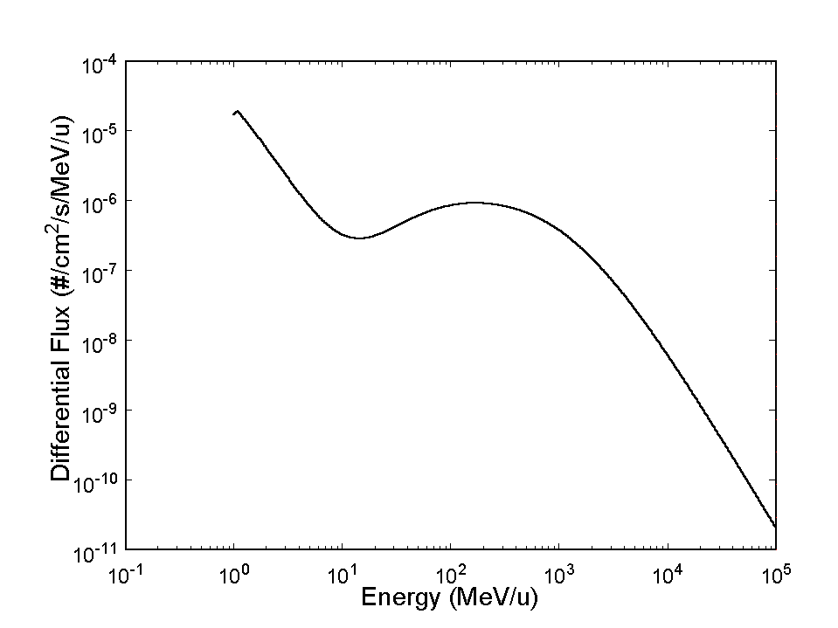
Fig. 1. Interplanetary galactic cosmic ray iron ion counts as a function of ion energy. Note that "Fig." is abbreviated. There is a period after the figure number, followed by two spaces. It is good practice to explain the significance of the figure in the caption. This figure was originally created in a graphics program, AXUM. The graph was copied as "Copy Graph Sheet Page" to the Windows Clipboard. In PowerPoint, a new file was opened and the contents of the Clipboard were pasted as a "Picture (Enhanced Metafile)". It was then saved as a TIFF formatted file named 1FIG.TIF. The image file was then inserted into this Word document as a "Picture".

Figure axis labels are often a source of confusion. Use words rather than symbols. As an example, write the quantity "Energy," or "Energy, E," not just "E." Put units in parentheses. Do not label axes only with units. As in Fig. 1, for example, write "Energy (MeV/u)" or "Energy ()," not just "MeV/u." Do not label axes with a ratio of quantities and units. For example, write "Temperature (K)," not "Temperature/K."
Multipliers can be especially confusing. Write "Dose (krd/s)" or "Dose (10³ rd/s)." Do not write "Dose(rd/s) 1000" because the reader would not know whether an axis label of 16 meant 16000 rd/s or 0.016 rd/s. Figure labels should be legible, approximately 8 to 10 point type.
To provide consistent reproducibility, please include axes and tick marks on all four sides of your graphs and avoid the use of grid lines (note that grid lines tend to clutter a graph if dark or reproduce poorly if light). Please also include an explanatory legend within your graphs when two or more curves or sets of data are included. Avoid explaining the different symbols and curves in the figure caption alone - using a legend results in a much more easily understood figure.

References
Number citations consecutively in square brackets [1]. The sentence punctuation follows the brackets [2]. Multiple references [2], [3] are each numbered with separate brackets [1]–[3]. When citing a section in a book, please give the relevant page numbers [2]. In sentences, refer simply to the reference number, as in [3]. Do not use “Ref. [3]” or “reference [3]” except at the beginning of a sentence: “Reference [3] shows ... .” Type the reference list at the end of the paper using the “References” style.
Please note that the references at the end of this document are in the preferred referencing style. Give all authors’ names; do not use “et al.” unless there are six authors or more. Use a space after authors' initials. Papers that have not been published should be cited as “unpublished” [4]. Papers that have been submitted for publication should be cited as “submitted for publication” [5]. Papers that have been accepted for publication, but not yet specified for an issue should be cited as “to be published” [6]. Please give affiliations and addresses for private communications [7].
Capitalize only the first word in a paper title, except for proper nouns and element symbols. For papers published in translation journals, please give the English citation first, followed by the original foreign-language citation [8].

Abbreviations and Acronyms
Define abbreviations and acronyms the first time they are used in the text, even after they have already been defined in the abstract. Abbreviations such as IEEE, SI, ac, and dc do not have to be defined. Abbreviations that incorporate periods should not have spaces: write "C.N.R.S.," not "C. N. R. S." Do not use abbreviations in the title unless they are unavoidable (for example, IEEE in the title of this article).

Equations
Number equations consecutively with equation numbers in parentheses flush with the right margin, as in (1). To make your equations more compact, you may use the solidus ( / ), the exp function, or appropriate exponents. Use parentheses to avoid ambiguities in denominators. Punctuate equations when they are part of a sentence, as in
(1)
Be sure that the symbols in your equation have been defined before the equation appears or immediately following. Refer to "(1)," not "Eq. (1)" or "equation (1)," except at the beginning of a sentence: "Equation (1) is ..."

Other Recommendations
Use one space after periods and colons. Hyphenate complex modifiers: "zero-field-cooled magnetization." Avoid dangling participles, such as, "Using (1), the potential was calculated." Write instead, "The potential was calculated by using (1)," or "Using (1), we calculated the potential."
Use a zero before decimal points: "0.25," not ".25." Use "cm³," not "cc." Indicate sample dimensions as "0.1 cm × 0.2 cm," not "0.1×0.2 cm²." Do not mix complete spellings and abbreviations of units: use "J/cm²" or "fluence per square centimeter," not "fluence/cm²." When expressing a range of values, write "7 to 9," not "7-9" or "7~9," except for references [1]-[3].
Use the correct format for scientific notation in text, tables, and figures. Computer notation of "E" for "10" is not permitted. For example, numbers expressed as 6.02E-3, instead of 6.0210, are not acceptable.
A parenthetical statement at the end of a sentence is punctuated outside of the closing parenthesis (like this). (A parenthetical sentence is punctuated within the parentheses.) In American English, periods and commas are within quotation marks, like "this period." Other punctuation is "outside"!
If you wish, you may write in the first person singular or plural and use the active voice ("I observed that ..." or "We observed that ..." rather than "It was observed that ..."). If your native language is not English, please get a native English-speaking colleague to proofread your paper.

Some Common Mistakes
The word "data" is plural, not singular. The subscript for the permeability of vacuum is zero, not a lowercase letter "o." Use the word "micrometer" instead of "micron." A graph within a graph is an "inset," not an "insert." The word "alternatively" is preferred to the word "alternately" (unless you really mean something that alternates). Do not use the word "essentially" to mean "approximately" or "effectively." Be aware of the different meanings of the homophones "affect" and "effect," "complement" and "compliment," "discreet" and "discrete," "principal" and "principle." Do not confuse "imply" and "infer."
Prefixes such as “non,” “sub,” “micro,” “multi,” and “ultra” are not independent words; they should be joined to the words they modify, usually without a hyphen. There is no period after the “et” in the Latin abbreviation “et al.” (it is also italicized). The abbreviation “i.e.,” means “that is,” and the abbreviation “e.g.,” means “for example” (these abbreviations are not italicized).
An excellent style manual and source of information for science writers is [9]. A general IEEE style guide, Information for Authors, is available at http://www.ieee.org/portal/cms_docs/pubs/transactions/auinfo03.pdf.

Appendix
Appendices, if needed, appear before the acknowledgment.

Acknowledgment
The preferred spelling of the word "acknowledgment" in American English is without an "e" after the "g." Use the singular heading even if you have many acknowledgments. Avoid the expression, "One of us (S.B.A.) thanks ..." Instead, write "S.B.A. thanks ..." Put sponsor acknowledgments in the unnumbered footnote on the first page.
We thank Tony Seibert for writing the original version of this document and Bo Yu for the following versions.
We thanks Bo Yu for making the submission website available to the Real Time Conference, and for all the help and support he constantly gives us.

References
- F. W. Sexton, D. M. Fleetwood, M. R. Shaneyfelt, P. E. Dodd, and G. L. Hash, "Single event gate rupture on thin gate oxides," IEEE Trans. Nucl. Sci., vol. 44, no. 6, pp. 2345-2352, Dec. 1997.
- J. Clerk Maxwell, A Treatise on Electricity and Magnetism, 3rd ed., vol. 2. Oxford: Clarendon, 1892, pp. 68-73.
- I. S. Jacobs and C. P. Bean, "Fine particles, thin films and exchange anisotropy," in Magnetism, vol. III, G. T. Rado and H. Suhl, Eds. New York: Academic, 1963, pp. 271-350.
- K. Elissa, "Title of paper," unpublished.
- R. Nicole, "Title of paper with only first word capitalized," J. Name Stand. Abbrev., submitted for publication.
- J. Wang, “Fundamentals of erbium-doped fiber amplifiers arrays (Periodical style—Submitted for publication),” IEEE J. Quantum Electron., submitted for publication.
- C. J. Kaufman, Rocky Mountain Research Laboratories, Boulder, CO, personal communication, 1992.
- Y. Yorozu, M. Hirano, K. Oka, and Y. Tagawa, "Electron spectroscopy studies on magneto-optical media and plastic substrate interface," IEEE Transl. J. Magn. Jpn., vol. 2, pp. 740-741, August 1987 [Dig. 9th Annual Conf. Magn. Jpn., p. 301, 1982].
- M. Young, The Technical Writer's Handbook. Mill Valley, CA: University Science, 1989.

Manuscript received April 3, 2012. (Write the date on which you submitted your paper for review.) This work was supported in part by the U.S. Department of Commerce under Grant No. BS123456 (sponsor acknowledgment goes here). Paper titles should be written in uppercase and lowercase letters, not all uppercase. Avoid writing long formulas with subscripts in the title; short formulas that identify the elements are acceptable (e.g., "Nd-Fe-B"). Do not write "(Invited)" in the title. Do not begin a title with the word "On ... ." Full names of authors are preferred in the author field, but are not required. Put a space between authors' initials. Do not use all uppercase for authors' surnames. F. A. Author is with the National Institute of Standards and Technology, Boulder, CO 80303 USA (telephone: 303-497-3650, e-mail: author @boulder.nist.gov). S. B. Author, Jr., was with Rice University, Houston, TX 77005 USA. He is now with the Department of Physics, Colorado State University, Ft. Collins, CO 80523 USA (telephone: 970-491-6206, e-mail: author@lamar. colostate.edu). T. C. Author is with the Electrical Engineering Department, University of Colorado, Boulder, CO 80309 USA, on leave from the National Research Institute for Metals, Tsukuba, Japan (e-mail: author@nrim.go.jp).

